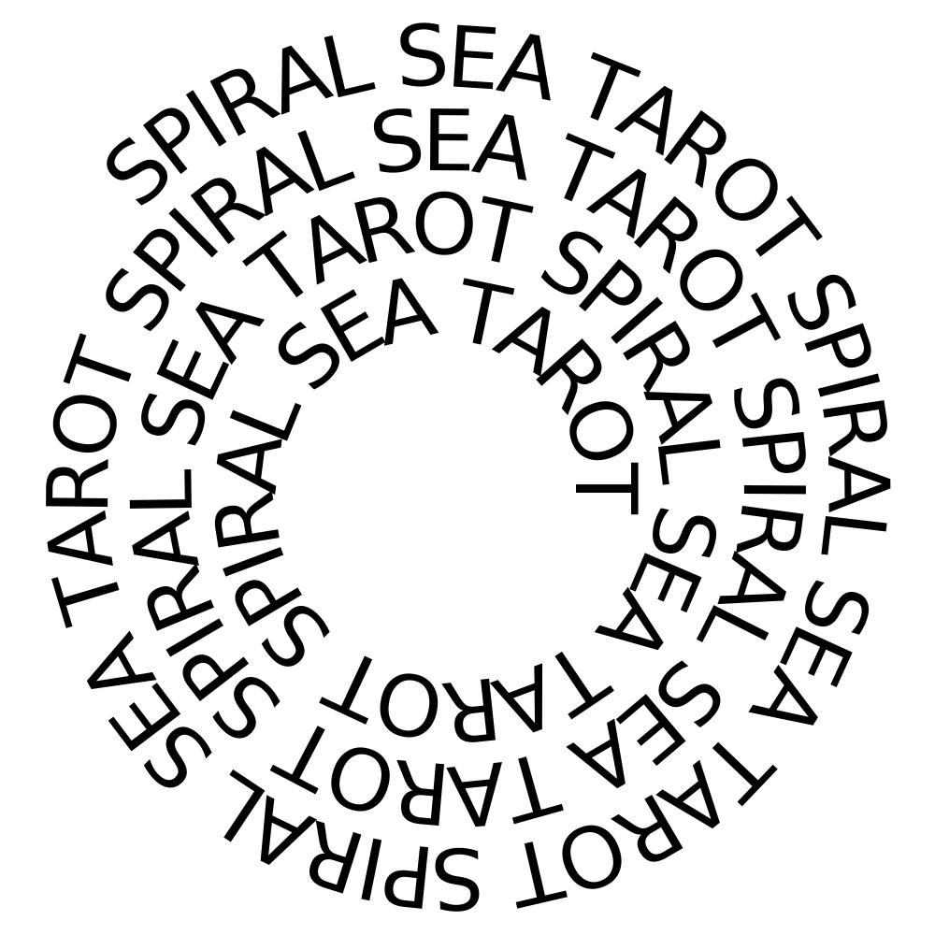
[replace with your logo]
Your Personal Reading Report
[reading type/name if applicable]
Name:
Date of Birth:
Location:
Date of Reading:

[insert your disclaimer here]

[insert your logo or relevant image here]

This is similar to the opening which I use but it would be suggested that you find your own language that suits your particular brand and style! “Greetings, [name]! I hope this reading finds you well. Below you will see the foundation of your reading followed by the layout, interpretations and pictures of the cards drawn. Please do keep in mind that these insights should be regarded as a means to assess the overall and immediate energy of a situation; tarot is about direction and the future isn’t written in stone!”

Reading Type/Inquiry: [insert type of reading or inquiry here]
Process: Here you can explain a bit about the reading they’ve selected, the deck you’ve chosen to use and how you plan to structure the reading on the following pages. If someone is ordering a specific reading type that requires some background information i.e. my spirit guide reading, I will explain the concept of the reading so that they can better understand the information that is to follow.

Card 1 - [positional meaning] - [card pulled]:
Here you can elaborate on the card that was pulled and what it means in the context of the position where it landed.

Card 2 - [positional meaning] - [card pulled]:
Here you can elaborate on the card that was pulled and what it means in the context of the position where it landed.

Card 3 - [positional meaning] - [card pulled]:
Here you can elaborate on the card that was pulled and what it means in the context of the position where it landed.

If you pull additional oracle or tarot cards, you can include that here with applicable interpretations. When I do this, I generally frame it as such: “[Client name], I wanted to pull an additional oracle card to add to some of these messages. The deck that I was drawn to work with in this case was Miracles Now for a written affirmation. For this pull, I asked that you be presented with something you needed to focus on and hear right now. This is the message you received:”

"I let my intimate relationships be my biggest learning devices for spiritual growth and healing."
At this point, it would be wise to take the opportunity to tie the oracle message into the rest of the reading.

Now, you can wrap up the entirety of the reading by using 1 or 2 paragraphs to summarize the messages, themes or points of focus. If there are additional resources you would like to include, links or other added extras custom to them, this would also be an appropriate place to include that.

Sincerely thank your client for allowing you the opportunity to read for them/work with them.

Invite their feedback and offer ways in which they can find you if need be. Include your email address, website or any social media.

Thank the client again and advise that their images can be found on the following page(s).

-your name

Image(s) of Your Reading

[insert large, high resolution image(s) here]

